Testing with ION
This document describes how to confiure ION to forward bundles from the HDTN bpgen tool to the HDTN bpsink tool. This will ensure that both sending and receiving bundles with a specific convergence layer is compatible with ION.
The simple network configuration is shown in Figure 1.
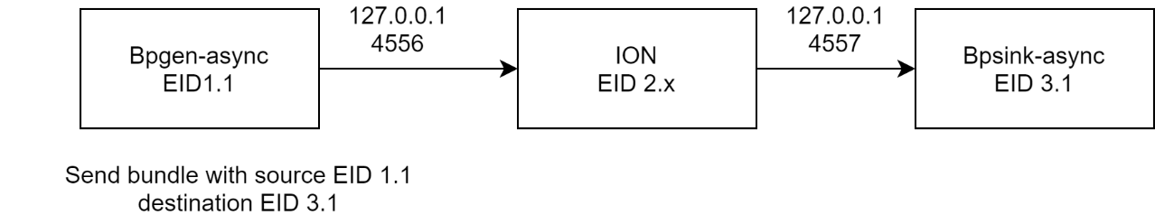
Figure 1. Basic test set up
The ION configurations in this folder are based on the demos that distributed with ION found in ion-open-source-3.7.2/demos.
- You will first need to download ION from https://sourceforge.net/projects/ion-dtn/
and follow the installation instructions.
- To verify ION is installed correctly run one of the demo scripts:
  - cd ./ion-open-source-3.7.2/demos/bench-stcp
  - ./dotest

Test HDTN STCP with ION
In one terminal:
- cd ./hdtn/build/common/bpcodec/apps
- ./bpsink-async --use-stcp --tcpcl-eid="ipn:3.1"
In another terminal:
- cd ./hdtn/tests/compatibility_tests/ion_stcpcl
- ./stcp-hdtn
- you will see the following output and ION will now run its processes in the background

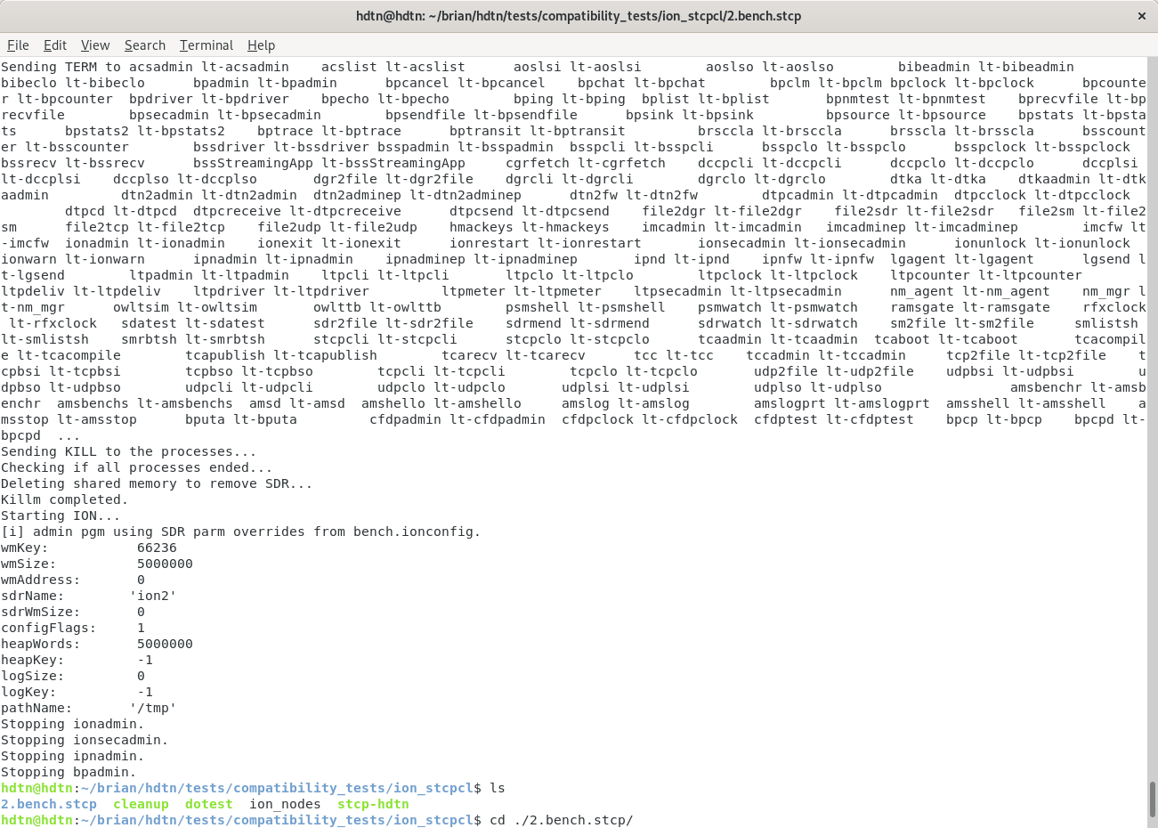
In another terminal:
- cd ./hdtn/build/common/bpcodec/apps
- ./bpgen-async --use-stcp --bundle-rate=1 --tcpcl-eid="ipn:1.1" --bundle-size=1000
Now ION will forward bundles from bpgen-async to bpsink-async. Press control-c in the terminal running bpgen-async when you are finished. Next, press control-c in the terminal running bpsink-async. Both programs will output the number of bundles received and other statistics.
To view the status of ION:
- cd ./hdtn/tests/compatibility_tests/ion_stcpcl/2.bench.stcp
- cat ion.log
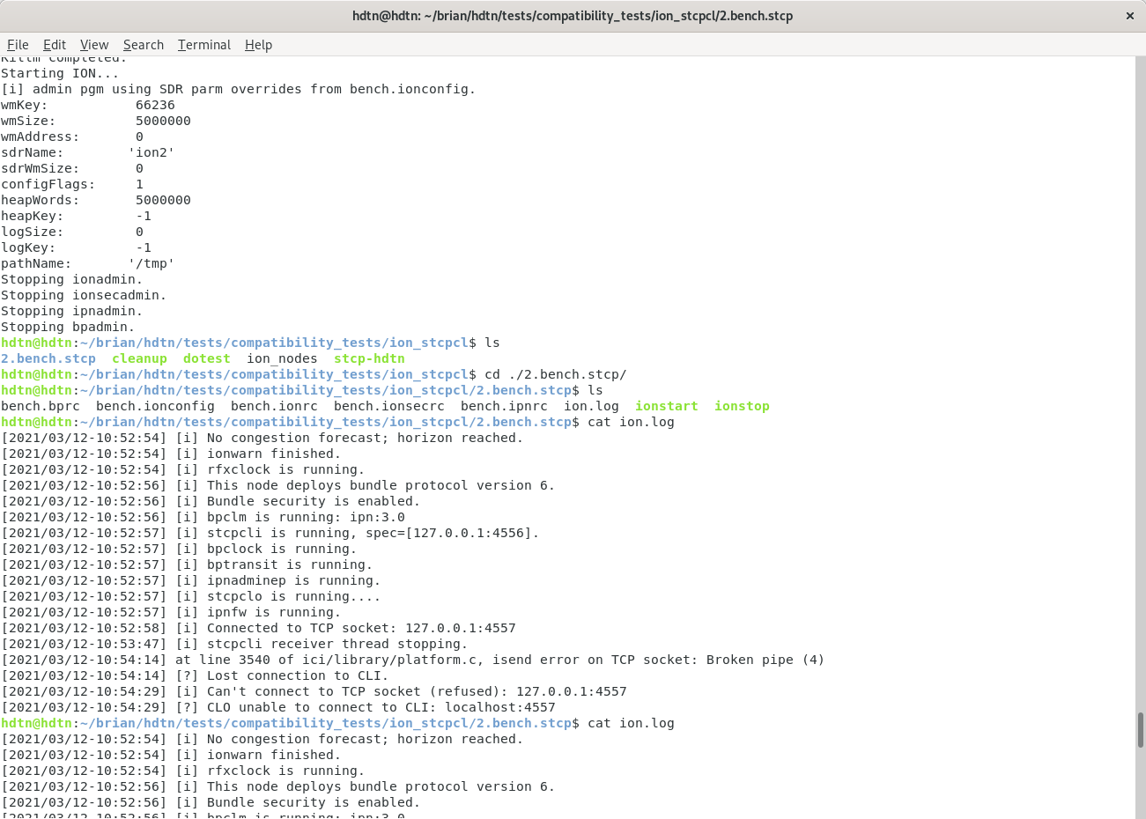

To stop ION:
- cd /hdtn/tests/compatibility_tests/ion_stcpcl/
- ./cleanup
This will stop all ION processes and delete the Spacecraft Data Recorder (SDR), the shared memory that ION uses to store bundles, and its working memory.

Test HDTN TCPCL with ION
The process is very similar to stcp.
In one terminal:
- cd ./hdtn/build/common/bpcodec/apps
- ./bpsink-async --use-tcpcl --tcpcl-eid="ipn:3.1"
In another terminal:
- cd ./hdtn/tests/compatibility_tests/ion_tcpcl
- ./tcp-hdtn
In another terminal:
- cd ./hdtn/build/common/bpcodec/apps
- ./bpgen-async --use-tcpcl --bundle-rate=1 --tcpcl-eid="ipn:1.1" --bundle-size=1000
You can also change the bundle rate and bundle size parameters

